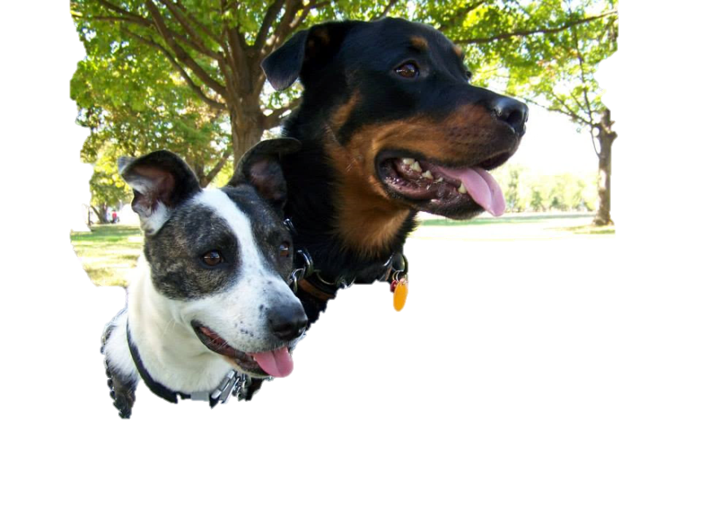
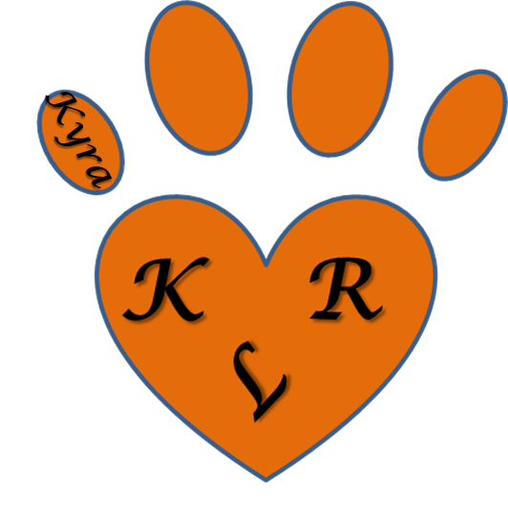
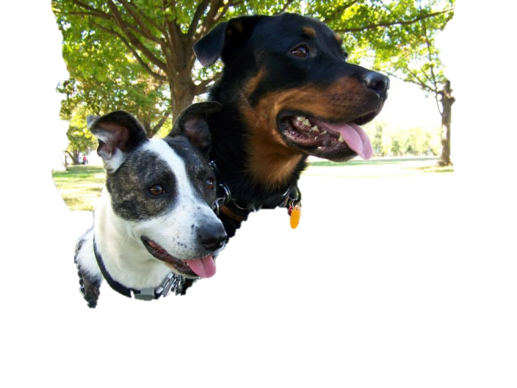

Kyra's Legacy Rescue (KLR)
Kyrasrescue@gmail.com

Name & Breed of Dog__________________________
Date________________________________________

DOG ADOPTION APPLICATION

This form and a consultation with a KLR representative are designed to help you find the dog most compatible with your lifestyle. Completion of this application does not guarantee adoption of a KLR dog. Please respond to the questions below as completely as possible.

In order to be considered as an adopter you must:
1. Be 21 years of age or older 2. Have a valid driver’s license or other government-issued ID 3. Have proof of the knowledge and consent of your landlord if renting 4. Be willing and able to provide proper care, training and medical treatment

Name: Street Address:

City: Home
phone:

State: Cell
phone:

Zip: Work
phone:

Email address:

Occupation:

Employer:

Employer Address:

Number of Adults in Household
Number of Children
Ages of Children

Are all the adults in your household aware that you are adopting a dog and in agreement? yes no
Who will be the primary caregiver for your new dog? Is any member of the household allergic to dogs?_ What type of housing do you live in? house apartment condo other

Do you own or rent?

Landlord’s name & phone #

Do you have a completely fenced yard? What kind of fence? Height Gate?

Do you have a pool?
If yes, is it fenced?

Why do you want a dog?

What qualities are you looking for in your new dog?

Which of the following behaviors would be a serious problem for you? Excessive barking digging jumping a fence not getting along with cats not getting along with other dogs not good with children not housetrained too active not playful with other
animals not playful with children not good being left alone difficult to walk on a leash too big too much shedding Other:

How many hours each day will the dog be left alone? Where will the dog be kept when alone?

Where will the dog be when you are home? Where will the dog sleep at night?

Are there times when the dog will be tied outside? If yes, when?

How often and what type of exercise will you give your dog?_
Is this your first dog? yes no

If you presently have a companion animal(s), please complete:
Name | Breed | Age | Gender | Spayed/  neutered? | Current on vaccines?

If you have previously had a companion animal(s), please complete:
Name | Breed | Years owned | What happened?

Name of your veterinarian _City/Town

Have you ever turned a pet into a shelter? If yes, explain_

Are you planning to attend obedience classes with your new dog?

If your new dog is not housebroken, how will you correct him/her when there is an accident, and what method will you use to train

him/her?

How long do you expect housetraining to take?_ When you go on vacation/travel, who will care for the dog?
How much are you willing to spend on medical bills for your dog? What would you do if the bills go over this amount?

Are you ready to take responsibility for this dog/puppy for the next 10-15 years? What provisions will you make for the dog should you become unable to care for it ?_
Are you willing to have a representative of KLR visit where the dog will be living?

INTERVIEWERS, Please initial that you have discussed the following topics: heartworm/ flea /tick prevention transition advice vaccines ID tag/KLR tag crating chewing exercise needs return policy fees medical records/ expenses

I certify that the information above is true and understand that false information will result in nullification of this adoption.

Prospective Adopter Signature: Date:

Interviewer Approval:_ Date: Interviewer Approval:_ Date:

